**PRACTICAL NO 01**

1. **MongoDB Basics .**
2. **Write a MongoDB query to create and drop database.**

* **DataBase Creatation .**

Query : use student ;

**OUTPUT :**



* **Drop database .**

Query : db.dropDatabase();

**OUTPUT :**

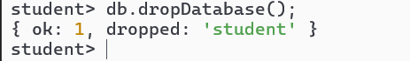

1. **Write a MongoDB query to create, display and drop collection**

* **Creation of collection.**

**Query :**

db.collection.insertMany([{"id ": 1 , "name" : "TG" ,"address " :"Khanoli"},{"id ": 2 ," name ": "PDK" , "address ":"Vengurla"}]);

**OUTPUT** :

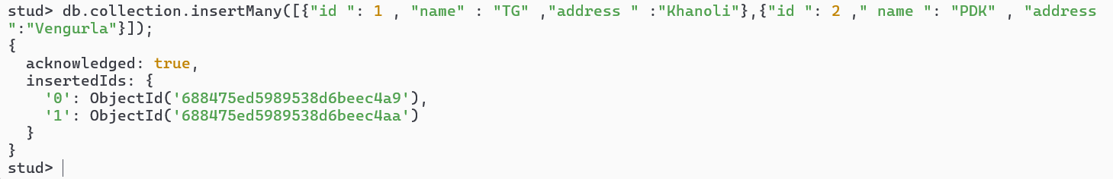

* **Displaying Collection data**

**Query :**

Db.collection.find({},{“_id” :0});

**OUTPUT :**

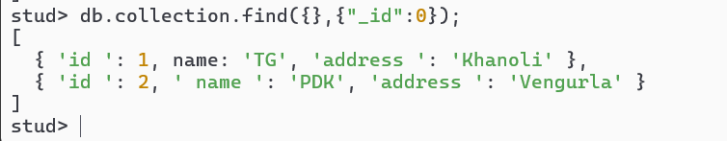

* **Drop Collection :**

**Query :**

Db.collection.drop();

**OUTPUT :**

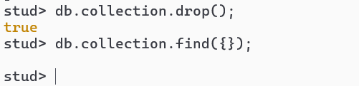

1. **Write a MongoDB query to insert, update and delete a document.**

* **Insert Document :**

**Query Only one Document :**

db.collection.insertOne({"id ": 6 , "name" : "Viraj" ,"address " :"Dabholi"});

**OUTPUT :**

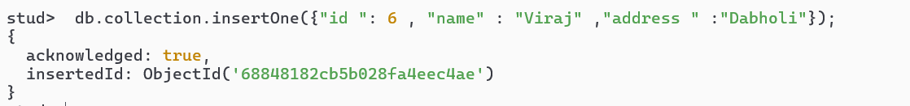

**Query Many Document :**

db.collection.insertMany([{"id ": 3 , "name" : "Tanu" ,"address " :"Madyachiwadi"},{"id ": 4 ," name ": "Harsh" , "address ":"Tendoli"},{"id": 5 , "name" : "Chitrang", "address" : "Path"}]);

**OUTPUT :**

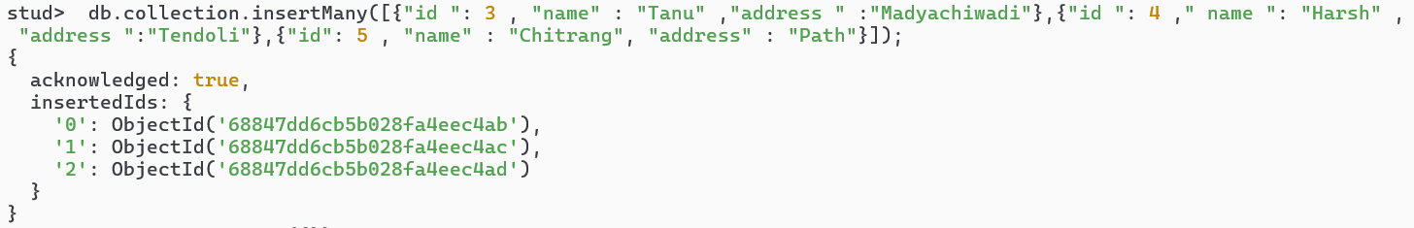

* **Update Document :**

**Query :**

db.collection.updateOne({"id ":1},{ $set :{name:"Yash"}});

**OUTPUT :**

**Before Updation :**

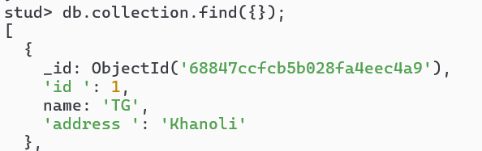

**Update Query :**

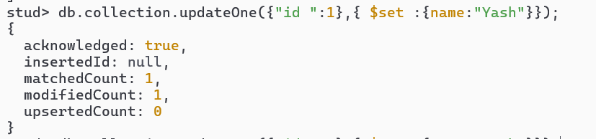

**Updated Document :**

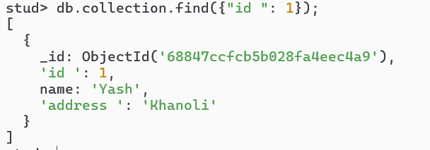

* **Delete Document :**

**Query :**

db.collection.deleteOne({"id ": 6});

**OUTPUT :**

**Before Delete :**

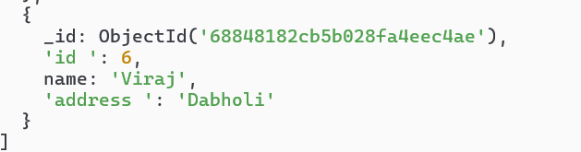

**Delete Query :**



**After Deletion:**

